Crash Course #1: The Agricultural Revolution
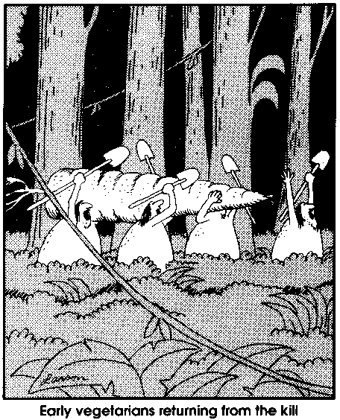
Watch this video:
http://www.youtube.com/watch?v=Yocja_N5s1I&index=1&list=PLBDA2E52FB1EF80C9
Answer these questions completely and in detail:
- How do we have evidence of Hunter-Gatherers (H-G) and their ways of life?

- What do most early civilizations have in common?

- What advantage did the H-G have over early agriculturalists?

- Where did agriculture emerge? Which food crops are associated with which areas?

- What are the advantages and disadvantages of agriculture?

- What impact does agriculture have on the environment?

- What other way of life emerged besides being a H-G or a farmer (agriculturalist)?

- What were the advantages and disadvantages of Pastoralism (being a herder)?

- Welcome to the MONGOLS! We love talking about the Mongols because we are the… ___________________!

- What advantages do you think that Eurasia had with its zoological set of animals compared to the Americas?

- Evaluate John Green’s thesis that “the greatest evolutionary advantage an animal species can have is being useful to humans.” Agree/disagree? Why?

- If H-G had a “better and healthier” way of life, why did people become agriculturalists?

- What point do you think John Green is making about the use of the word “savage”? How might this also apply to concepts of being “civilized” or “uncivilized”?

- What do historians say are the drawbacks to complex civilizations and agriculture?

- What other impacts do complex civilizations have on the environment?

- What does John Green say about “revolutions”?

