Crash Course #10: The Roman Empire
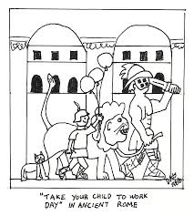
Watch this video:
https://www.youtube.com/watch?v=oPf27gAup9U&index=10&list=PLBDA2E52FB1EF80C9
Answer these questions completely and in detail:
- What does SPQR stand for?

- Describe the government of the Roman Republic. Include the senate, consuls, and dictator.

- Who were the patricians and plebeians?

- Describe Caesar’s rise to power.

- Who were the members of the First Triumvirate?

- How did Caesar take control of the Roman Empire?

- Once in power, how did Caesar strengthen his own position?

- Why didn’t Caesar assassination by the Senators restore the Republic?

- How did Octavian (Augustus) become sole ruler of Rome?

- How was the government different from the Republic under the emperors?

- In what ways was Rome an empire even before Caesar came along?

