Crash Course #12: The Fall of Rome- The Byzantine Empire
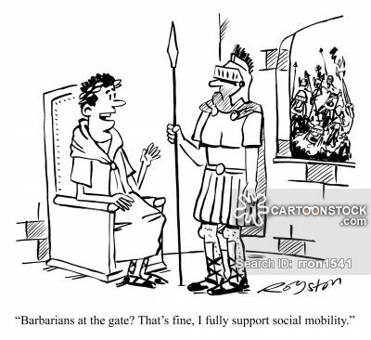
Watch this video:
http://www.youtube.com/watch?v=3PszVWZNWVA&list=PLBDA2E52FB1EF80C9&index=12
Answer these questions completely and in detail:
- What happened in 476 CE? Explain.

- What problems did Rome face before the collapse of the Western Empire?

- Why was it problematic for Rome to give generals so much power?

- Pants: symbol of oppression or downfall of civilization? Discuss.

- In what way did the Roman Empire survive until the 15th century?

- Why did Constantine move his capital to the East?

- What were the continuities between the Eastern and Western Roman Empires? What was different?

- Who was the most famous Byzantine emperor after Constantine? Why?

- Describe the Empress Theodora and her accomplishments.

- How was eastern Christianity (Orthodox) different from western Christianity (Roman Catholicism)?

