Crash Course #13: Islam
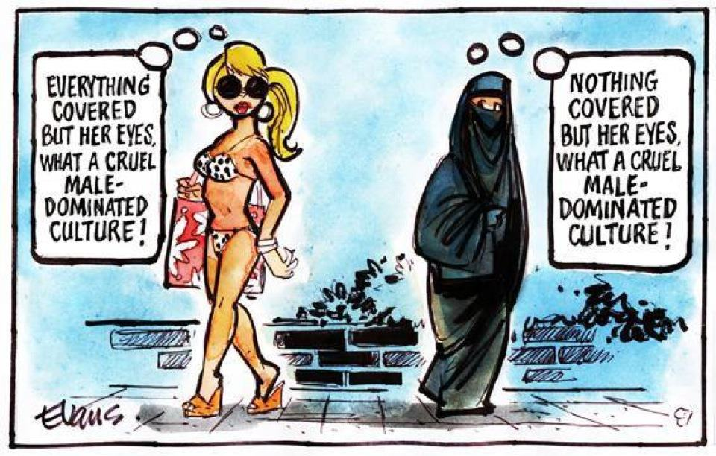
Watch this video:
http://www.youtube.com/watch?v=TpcbfxtdoI8&index=13&list=PLBDA2E52FB1EF80C9
Answer these questions completely and in detail:
- Why do you think average Americans know so little about Islamic history?

- Briefly describe the beginning of Islam (through the life of Muhammad).

- What are the Five Pillars of Islam? Describe them?

- What is shari’a?

- Why was Muhammad opposed by the Qurush of Mecca?

- Why are religion and government so closely intertwined in Islam?

- Who are the caliphs?

- What are the two major branches of Islam? Why did they divide?

- How did early Islam spread? Give several methods.

- What benefits came out of the Islamic empires?

