Crash Course #14: The Dark Ages
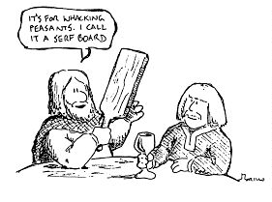
Watch this video:
http://www.youtube.com/watch?v=QV7CanyzhZg&list=PLBDA2E52FB1EF80C9&index=14
Answer these questions completely and in detail:
- Why is 600-1450 called the Middle Ages in Europe? Why is it called the Dark Ages?

- Do you think these names are accurate?

- What is this period like outside of Europe?

- What is feudalism? Describe it.

- Compare Europe and the Muslim world at this time.

- Who are the Abbasids? Where was their capital?

- How did Abbasid expansion create problems similar to what occurred in the Roman Empire?

- List and describe some accomplishments of the Abbasids.

- Describe Spain under the Muslims.

- Describe China under the Tang and Song Dynasties.

