Crash Course #15: The Crusades
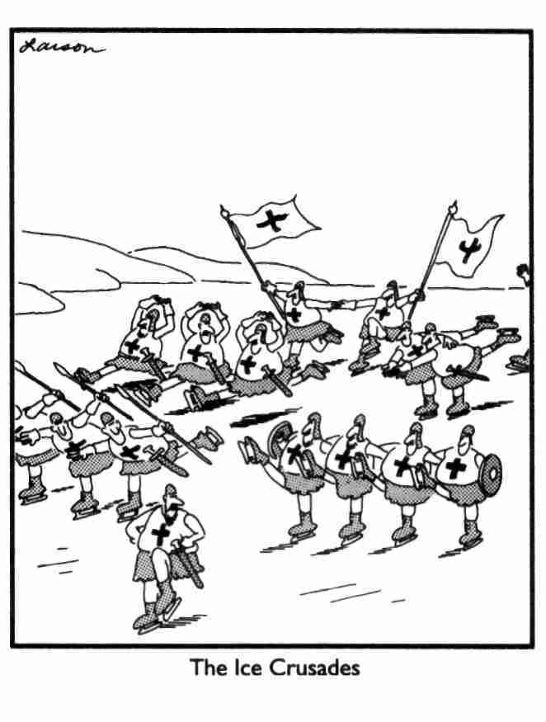
Watch this video:
http://www.youtube.com/watch?v=X0zudTQelzI&index=15&list=PLBDA2E52FB1EF80C9
Answer these questions completely and in detail:
- What are the Crusades? Why are they such a popular topic?

- How did the First Crusade begin? Why?

- What were the goals and motivations of the Crusades? Which do you think was the most important?

- Was the First Crusade a military success? Were any of the others?

- Who was Saladin? How did he inspire the Third Crusade?

- What kings went on the Third Crusade? What happened to them?

- Why is the Fourth Crusade the “crazy one”?

- Who conquered Constantinople in 1453?

