Crash Course #16: Mansa Musa
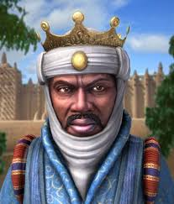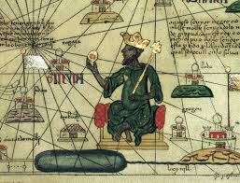
Watch this video:
http://www.youtube.com/watch?v=jvnU0v6hcUo&list=PLBDA2E52FB1EF80C9&index=16
Answer these questions completely and in detail:
- What is one problem with learning about the history of sub-Saharan Africa?

- Who is Mansa Musa? Describe his hajj.

- List some of the traditional stereotypes about Africa.

- How did Islam spread to sub-Saharan Africa?

- Who was Ibn Battuta and what did he do?

- How was Swahili East Africa organized politically? Give at least THREE other previous examples of this.

- What were the THREE common elements of Swahili culture?

- Describe the development of Swahili culture.

- What were the most important trade goods across the Sahara? In East Africa?

