Crash Course #17: The Mongols
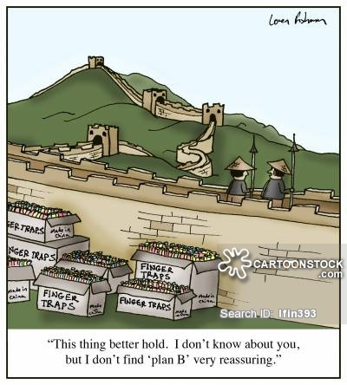
Watch this video:
https://www.youtube.com/watch?v=szxPar0BcMo&list=PLBDA2E52FB1EF80C9&index=17
Answer these questions completely and in detail:
- What is the traditional, stereotypical image of the Mongols?

- How is this perception challenged in modern history texts? What do they emphasize instead?

- Describe the lifestyle of nomadic groups.

- Who is Genghis Khan and why is he important?

- What two innovations did Genghis use for his success?

- What was the extent of the Mongol Empire?

- What happened to Genghis’ empire after his death? Be specific.

- Why was the Mongol military so successful?

- What are the 5 arguments for Mongol “awesomeness”? For each one, do you agree?

- What are the 5 arguments against Mongol “awesomeness”? For each one, do you agree?

- So, do you think the Mongols overall are good or bad? Why?

