Crash Course #18: The Indian Ocean (I.O.)
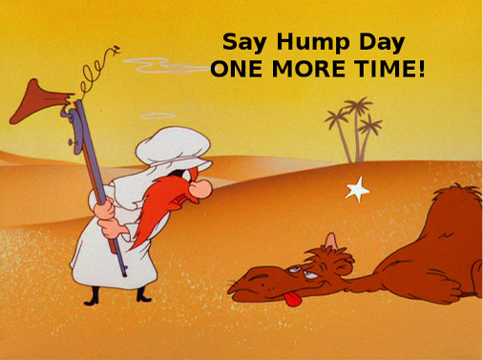
Watch this video:
http://www.youtube.com/watch?v=a6XtBLDmPA0&index=18&list=PLBDA2E52FB1EF80C9
Answer these questions completely and in detail:
- How was the Indian Ocean (I.O.) like the Silk Road?

- Why did the I.O. decline during the Pax Mongolica?

- Who was involved in I.O. trade? (Include areas and groups of people)

- Describe the monsoons and their impact.

- Why did Muslim merchants dominate trade in the western I.O.?

- How are the trade goods John Green describes a change from the goods traded early on the I.O.?

- What technology spread on the I.O.? What ideas?

- Why was the Strait of Malacca important for trade?

- Why might it be a problem for governments to rely too heavily on trade?

