Crash Course #19-2: Charles V… or is it I?
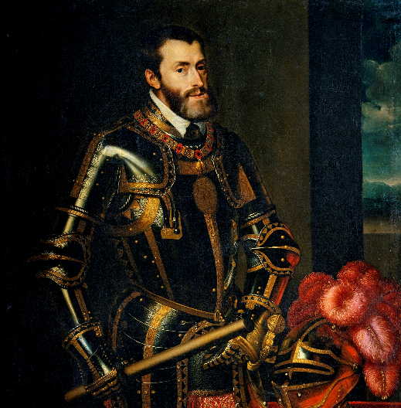
Watch this video:
https://www.youtube.com/watch?v=MRYzW3BSj0I&index=19&list=PL8dPuuaLjXtNjasccl-WajpONGX3zoY4M
Answer these questions completely and in detail:
- What was Charles’ called in Spain? In the rest of Europe?

- Describe the extent of Charles’ empire.

- List some of his accomplishments.

- What problems did Charles face during his rule?

- What were the problems faced by the Holy Roman Empire (HRE) throughout its history?

- Describe the formation and political development of the HRE.

- What are the benefits and drawbacks of keeping marriages within the family?

- Describe the lineage of Charles V.

- How did Charles attempt to address problems in the Americas?

- Describe the causes of and conflicts between Charles and Francis I.

- Would you describe Charles V’s reign as a success or failure? Why?

