Crash Course #19: Venice and the Ottoman Empire
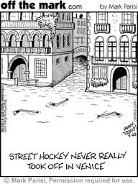
Watch this video:
https://www.youtube.com/watch?v=UN-II_jBzzo&index=19&list=PLBDA2E52FB1EF80C9
Answer these questions completely and in detail:
- Why did Venice rely on trade? How were they well suited to it?

- Why was the spice trade (pepper) so important for Europe?

- Where did most spices come from? What role did the Muslims play in the spice trade?

- How was Venice’s government different from many other parts of Europe? How did this benefit trade?

- Describe the Ottoman Empire. Include its foundation, important rulers, major accomplishments, and government.

- How did the Ottomans address the problem of a hereditary aristocracy? What do you think of their solution? Be sure to include the devshirme and janissaries.

- How did both Venice and the Ottoman Empire benefit from their relationship?

- How did other European powers react to Venice’s control of trade?

