Crash Course #2: Indus Valley Civilization (IVC)
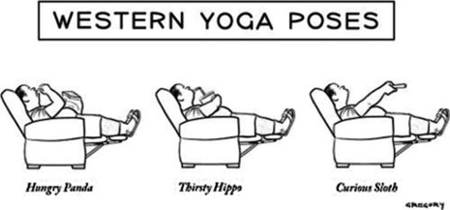
Watch this video:
http://www.youtube.com/watch?v=n7ndRwqJYDM&index=2&list=PLBDA2E52FB1EF80C9
Answer these questions completely and in detail:
- What other terms are used to describe people who are “uncivilized”?

- What might be the problems with classifying some groups as “civilized” and others as “uncivilized”?

- What are the common traits (“symptoms”) of civilizations?

- Where were the earliest civilizations located? Why?

- How do we know anything about the Indus Valley Civilization? Why is this knowledge so limited?

- List AT LEAST 5 impressive things historians do know about the IVC.

- What did the IVC trade? With whom?

- What happened to the people of the IVC? What did not happen to them?

- What and where are the Caucasus? (This is an outside research question- Google it!)

- Describe the three theories of the decline/disappearance of the IVC.

- Which theory do you find most plausible? Why?

