Crash Course #20: Russia and the Mongols
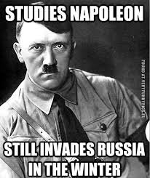
Watch this video:
https://www.youtube.com/watch?v=etmRI2_9Q_A&index=20&list=PLBDA2E52FB1EF80C9
Answer these questions completely and in detail:
- Describe Kievan Rus. Include their foundation, economy, religion, and fall.

- Describe the Mongol impact on Russia.

- How was Russia isolated from their neighbors? What was the impact of this?

- Why were Moscow’s rulers willing to ally with the Mongols?

- Describe the rule of Ivan III (the Great).

- Describe the rule of Ivan IV (the Terrible). Include both the good and bad.

- What is the Russian model of autocracy (absolutism)? How was it achieved?

