Crash Course #21- Columbus, da Gama, and Zheng He
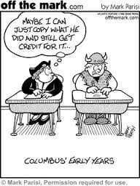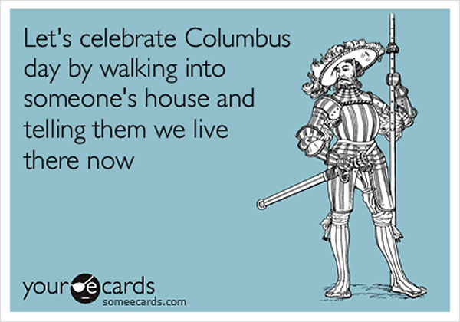
Watch this video:
https://www.youtube.com/watch?v=NjEGncridoQ&list=PLBDA2E52FB1EF80C9&index=21
Answer these questions completely and in detail:
- Review: Summarize Indian Ocean trade.

- Who is Zheng He? Describe his life and accomplishments.

- Compare Zheng He’s voyages to those of Columbus.

- Describe the Chinese tribute system and its impacts. What are some other groups we have talked about that used tribute systems?

- Why did the Chinese isolate themselves? What do you think this will do to China in the long run?

- List Portugal’s advantages and disadvantages in maritime trade.

- Who is Prince Henry the Navigator? What did he do?

- Who is Vasco da Gama? What did he do?

- Describe the Portuguese maritime empire.

- What are three common myths about Columbus? How are they wrong?

- How did the pope settle the dispute between Portugal and Spain?

- Describe Columbus’ accomplishments and their eventual impact on Spain and the New World.

- Why does John Green say that Columbus led to a “truly World History” for the first time?

- Do you think Columbus should be considered a hero or a villain of history?

