Crash Course #23- The Columbian Exchange
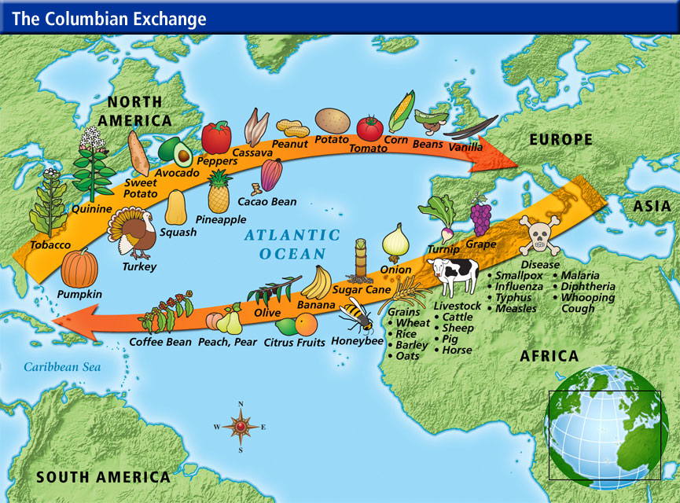
Watch this video:
https://www.youtube.com/watch?v=HQPA5oNpfM4&index=23&list=PLBDA2E52FB1EF80C9
Answer these questions completely and in detail:
- What is the Columbian Exchange (ColEx)? What does John Green mean when he says it “made the world ‘biologically singular’”?

- What are the categories of the ColEx?

- What was the most destructive part of the ColEx for Native Americans? Why?

- What were the other effects of the ColEx on the lives of Native Americans?

- What disease did Native Americans give to Europeans? Why might this be ironic?

- How did European animals change the Americas? Give specific examples.

- How did New World plants change the lives of AfroEurasians?

- How did the movement of people impact global populations?

- *Research Question* What is the African Diaspora? What other group of people had a diaspora that we talked about?

- Do you think the ColEx was good or bad overall? Why?

