Crash Course #24- The Atlantic Slave Trade
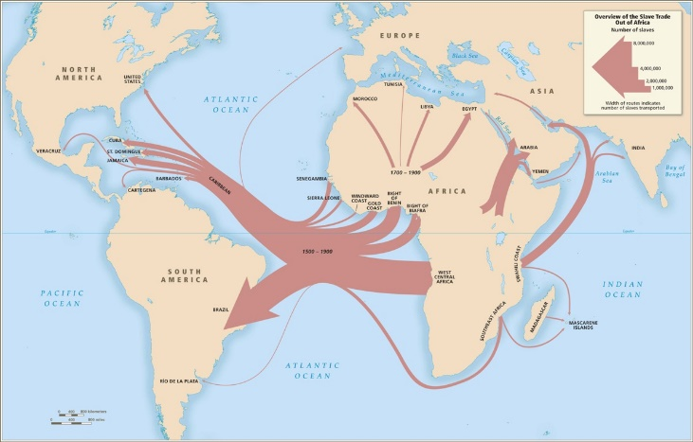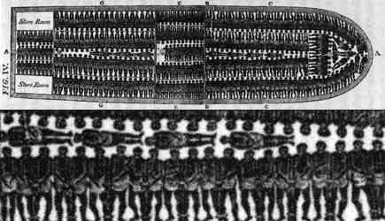
Watch this video:
https://www.youtube.com/watch?v=HQPA5oNpfM4&index=23&list=PLBDA2E52FB1EF80C9
Answer these questions completely and in detail:
- Give some statistics about the Atlantic slave trade.

- What were the primary crops grown by slaves? What kind of crops are these?

- How did Europeans get most of the African slaves? How were those people enslaved in the first place?

- What was the most common job for slaves in the Americas?

- Why did Brazil have to continually import new slaves, while the United States could end the slave trade yet continue to practice slavery?

- Compare the Atlantic (European) model of slavery with the others presented, especially Islamic slavery.

- How was slavery justified by Christian Europeans?

- How do you think modern Americans (you) should feel about our country’s history of slavery?

