Crash Course #25- The Spanish Empire
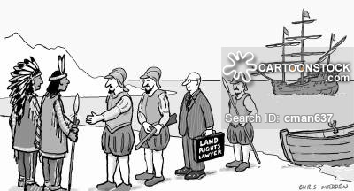
Watch this video:
https://www.youtube.com/watch?v=rjhIzemLdos&list=PLBDA2E52FB1EF80C9&index=25
Answer these questions completely and in detail:
- Review- Briefly describe the Aztec Empire using the elements of SPICE.

- Review- Briefly describe the Incan Empire using the elements of SPICE.

- How did the structure of the Incan and Aztec empires aid in Spanish conquest?

- What metal helped to transform the Spanish, and eventually the global economy? How?

- Why didn’t Spain gain substantial benefit from their new found wealth?

- How did American silver impact the Chinese economy? Be specific.

- Why didn’t the Ming Dynasty gain substantial benefit from their new found wealth?

- Do you think the costs of this period were worth the modern world they helped create today?

