Crash Course #26- The Seven Years War
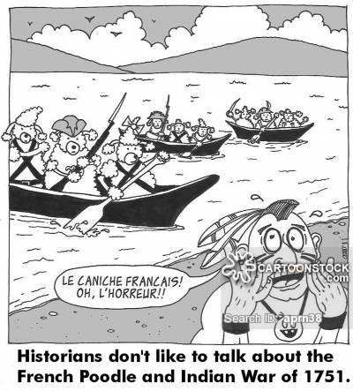
Watch this video:
https://www.youtube.com/watch?v=j0qbzNHmfW0&list=PLBDA2E52FB1EF80C9&index=26
Answer these questions completely and in detail:
- Why do historians generally like to talk about wars?

- Why is the Seven Years War (SYW) considered a ‘world war’?

- Describe the various sides in the SYW.

- Describe the causes of the SYW.

- Why did Native Americans predominantly support the French?

- Describe the lifestyle of North American Amerindians before the arrival of Europeans.

- Why was there fighting in the Caribbean? West Africa? India?

- What role did corporations play in the SYW?

- What was the impact of the SYW for France? For Britain?

