Crash Course #28- The American Revolution
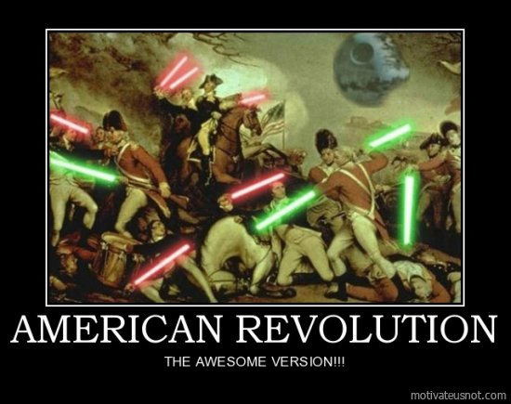
Watch this video:
https://www.youtube.com/watch?v=HlUiSBXQHCw&list=PLBDA2E52FB1EF80C9&index=28
Answer these questions completely and in detail:
- Why does John Green consider The Seven Years War to be the starting point for the American Revolution (AR)?

- Describe at least two events leading up to the AR.

- How did the Committees of Correspondence help to create an American government?

- What groups supported the British? Why?

- In what ways was the AR revolutionary? Be specific.

- In what ways was the AR not revolutionary? Be specific.

- What groups could and could not participate in the early American democracy? How did this compare to the language used in our country’s founding documents (The Declaration and Constitution)?

- What is the Enlightenment? How did it influence the AR?

- Do you think America lives up to its guiding principles? Why or why not?

