Crash Course #29- The French Revolution
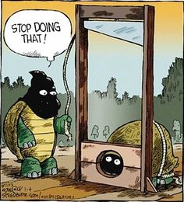
Watch this video:
https://www.youtube.com/watch?v=lTTvKwCylFY&index=29&list=PLBDA2E52FB1EF80C9
Answer these questions completely and in detail:
- Describe the problems France faced before the revolution.

- How did the American Revolution contribute to France’s problems?

- What is the Estates-General? Describe the three Estates.

- Describe the storming of the Bastille in Paris, an event now celebrated as France’s “Independence Day”.

- What is the Declaration of the Rights of Man and Citizen?

- Why did peasant women storm the Palace of Versailles? What was the result for Louis XVI and Marie Antoinette?

- Who are the Jacobins and what did they believe?

- Why did the events in France make their neighbors nervous?

- Why was the guillotine considered an Enlightenment method of execution? What do you think about the death penalty being “humane and equal”?

- What was “the Terror” and what was its purpose?

- In what ways was the French Revolution not very revolutionary?

- How might the French Revolution be considered more revolutionary than the American?

