Crash Course #3: Mesopotamia
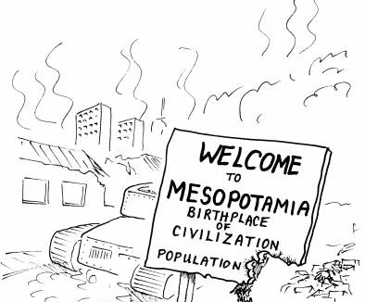
Watch this video:
http://www.youtube.com/watch?v=sohXPx_XZ6Y&index=3&list=PLBDA2E52FB1EF80C9
Answer these questions completely and in detail:
- What two things did Mesopotamia help create?

- Which do you think is worse- death or taxes?

- What rivers surround Mesopotamia?

- What is The Epic of Gigamesh? Does it contain any stories that are familiar to you?

- What are ziggurats? How did the priests of the ziggurat legitimize their power?

- Describe the gods of Mesopotamia.

- What are the problems with Mesopotamia’s rivers?

- How did the first kings legitimize their power?

- Analyze (APPROPRIATELY) the conflict and interaction between religious and political power in Mesopotamia.

- What is cuneiform? Why is this one invention so important to our knowledge of Mesopotamia?

- Why is writing so important? Give AT LEAST three points.

- Who is Hammurabi? What is his code? Describe it.

- Who are the Assyrians and why are they important? Describe their methods.

- Analyze the idea of city-states vs. empires.

