Crash Course #30- The Haitian Revolution
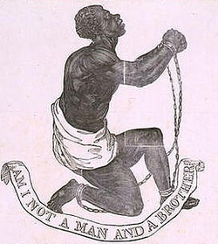
Watch this video:
https://www.youtube.com/watch?v=5A_o-nU5s2U&index=30&list=PLBDA2E52FB1EF80C9
Answer these questions completely and in detail:
- What became the basis of the Haitian economy (after piracy died down)?

- What were the four groups that made up Haitian society? Why did each group have problems with the current system?

- How did the French Revolution contribute to revolution in Haiti?

- Who is Toussaint L’Ouverture? What role did Spain and Britain play in Haiti’s revolution?

- How did Napoleon deal with Haiti when he came to power? Why?

- What problems did the French face in trying to maintain control of Haiti?

- Why do you think Haiti has so many problems today?

