Crash Course #31- The Latin American Revolutions
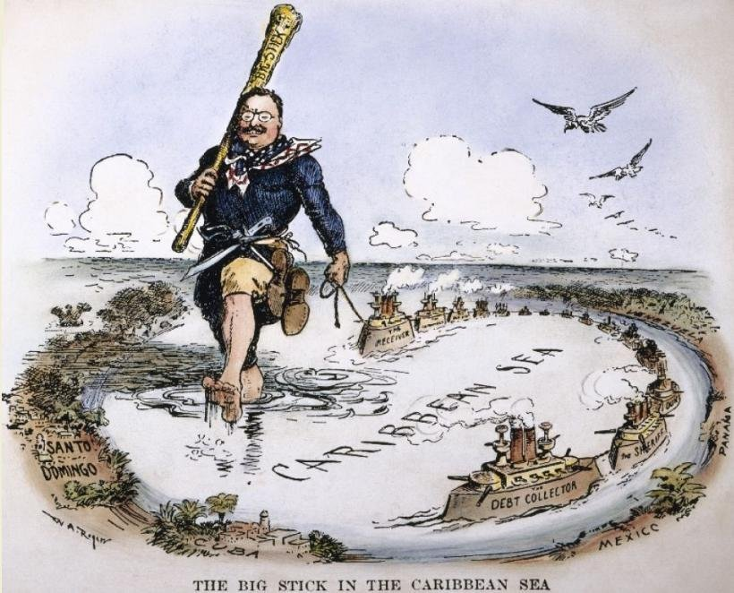
Watch this video:
https://www.youtube.com/watch?v=ZBw35Ze3bg8&list=PLBDA2E52FB1EF80C9&index=31
Answer these questions completely and in detail:
- What four things make the Latin American (L.A.) revolutions confusing?

- Name and describe the three institutions that controlled the L.A. population.

- Describe the racially based social classes of L.A. (this should be review from Unit 4).

- Briefly explain Brazil’s road to independence. Be sure to include Napoleon’s role.

- What happened to Brazil’s social structure after independence? Why?
- How did Napoleon create a division between the creoles and peninsulares? What side did Miguel Hidalgo support? Why was this problematic for non-white peasants?

- Why did the L.A. elites and the military prevent true social change in Mexico and the rest of L.A.?

- Who is Simon Bolivar? What did he do?

- In what ways were the L.A. revolutions successful?

- In what ways were they unsuccessful (not very revolutionary)?

