Crash Course #33- Capitalism vs. Communism
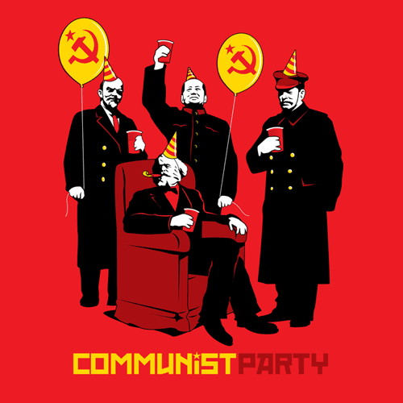
Watch this video:
https://www.youtube.com/watch?v=B3u4EFTwprM&list=PLBDA2E52FB1EF80C9&index=33
Answer these questions completely and in detail:
- How is industrial capitalism different from the previously used mercantile capitalism?

- How did agricultural improvements lead to the growth of consumerism and numerous available workers?

- How did capitalism change culture and society? Give several specific examples.

- What were some (at least 3) downsides of industrial capitalism?

- What were some of the potential solutions to these problems?

- What is socialism? What are the two types?

- Which communist revolutionary do you think has the best beard? Why? (The unnamed, bearded revolutionaries in order are: Vladimir Lenin, Leon Trotsky, Che Guevara, and Fidel Castro)

- Who is Karl Marx? What classes did he identify in England? What was their conflict?

- Do you believe competition is natural and good, or should people work together for our own common interests? Why? Are these ideas mutually exclusive?

