Crash Course #34- Nationalism and Japan
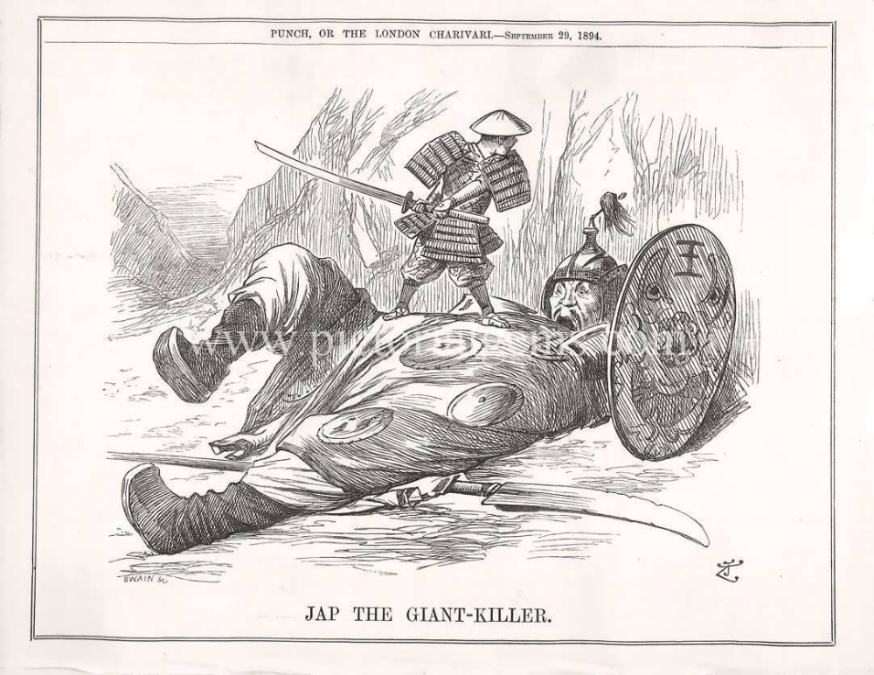
Watch this video:
https://www.youtube.com/watch?v=Nosq94oCl_M&list=PLBDA2E52FB1EF80C9&index=34
Answer these questions completely and in detail:
- How was nationalism a global phenomenon? Who were some nationalist leaders?

- What is a nation-state?

- What are some tools used to create shared national identities?

- List some examples of nationalistic wars or conflicts.

- How did nationalism impact multi-ethnic empires? Be specific.

- Describe the Japanese government under Tokugawa rule.

- What two regional events rocked Japan?

- Who was Matthew Perry and what did he do?

- In what ways did Japan create a modern nation-state?

- What role did public education play in creating nationalism? Do you think mandatory, free, public education is a good thing? Why or why not?

- Describe Japan’s imperial expansion.

