Crash Course #35- Imperialism
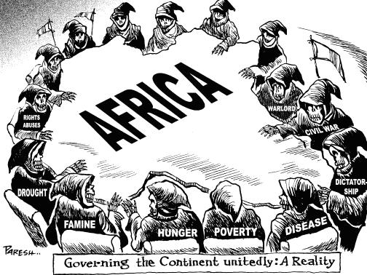
Watch this video:
https://www.youtube.com/watch?v=alJaltUmrGo&list=PLBDA2E52FB1EF80C9&index=35
Answer these questions completely and in detail:
- What product did the British finally find that China would buy? How did China react? What was the result?

- Describe Europe’s early involvement in Africa, especially under the Portuguese. Why was it so limited?

- What motivated imperialism? What allowed the Europeans to have so much imperial success?

- What three technologies gave Europeans full access to Africa?

- Give some examples of countries that were not colonized during this period.

- Describe the idea of indirect colonial rule. Why was this so common? Why did local leaders agree to it?

- What were the benefits of European rule for people of the colonies?

