Crash Course #36- World War I
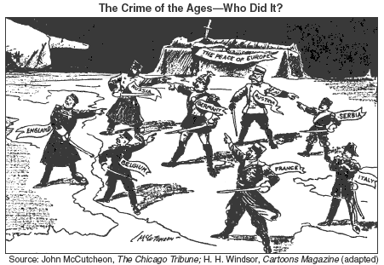
Watch this video:
https://www.youtube.com/watch?v=_XPZQ0LAlR4&list=PLBDA2E52FB1EF80C9&index=36
Answer these questions completely and in detail:
- Describe the causes of World War I (WWI). Include both the immediate and long term causes.

- Describe the fighting during WWI. Compare the Western Front with other battlefields.

- Describe the new technology and how it shaped WWI.

- Describe the Russian Revolution. How is it linked to WWI?

- Describe the impact of WWI on Germany, the U.S., the Ottoman Empire, the British Empire, and on post-war art and literature.

