Crash Course #39- The Cold War
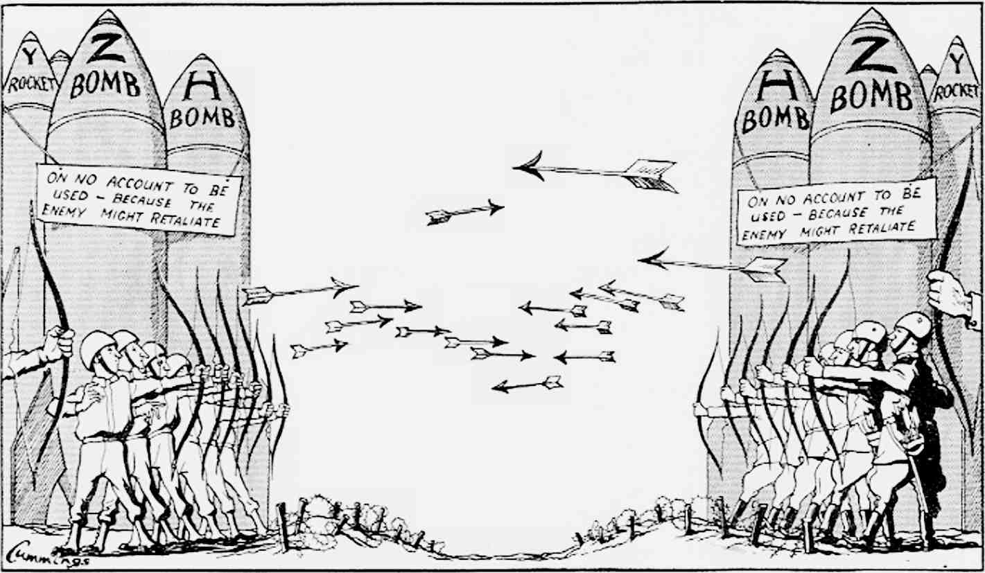
Watch this video:
https://www.youtube.com/watch?v=y9HjvHZfCUI&list=PLBDA2E52FB1EF80C9&index=39
Answer these questions completely and in detail:
- Describe the conflicting sides of the Cold War. Include the superpowers, their ideologies, and their methods.

- Describe the connection between the end of World War II and the Cold War.

- Describe the Cold War in Europe. Include the policy of containment, the Marshall Plan, and the impact of nuclear weapons (M.A.D.).

- Describe the Cold War in Asia, the Americas, and Africa.

- Who are the First, Second, and Third Worlds?

- Describe the failures of the Soviet Union and the end of the Cold War. Include the role of Mikhail Gorbachev and the policies of Glasnost and Perestroika.

