Crash Course #4: Ancient Egypt
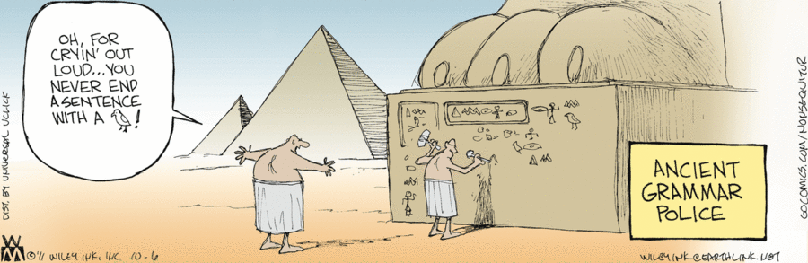
Watch this video:
http://www.youtube.com/watch?v=Z3Wvw6BivVI&index=4&list=PLBDA2E52FB1EF80C9
Answer these questions completely and in detail:
- What years did the Egyptian civilization span?

- Evaluate John Green’s statement that there are many approaches to studying history and each one has benefits and drawbacks. How does this support the statement, “history is not just learning about what a bunch of dead people did a long time ago.”?

- Describe the Nile River and the Egyptian’s relationship to it. Compare this to the Tigris and Euphrates on Mesopotamia.

- How did Egyptians view the afterlife, and how did this shape their cultural practices regarding death?

- Dates… ugh! Name, date, and briefly describe the three periods of Egyptian history.

- How did the pharaoh legitimize his power? Compare this with the kings of Mesopotamia.

- Describe the Egyptian gods and religious practices.

- What allowed nomadic invaders to conquer Egypt during the Middle Kingdom?

- What two things made pharaoh Hatshepsut different from other Egyptian rulers of the New Kingdom?

- Who was Akhenaten and what did he do?

- Describe King Tut(ankamun). Why is he so famous?

