Crash Course #42- Globalization, Part 2
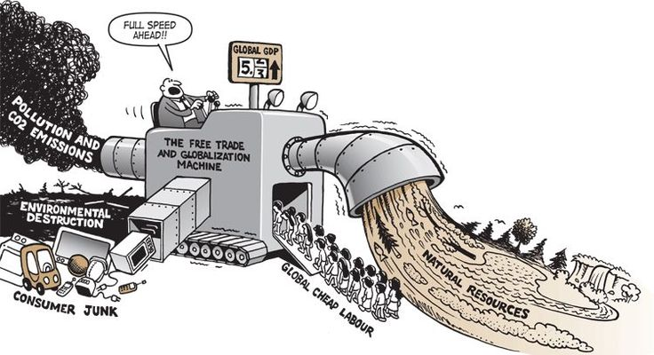
Watch this video:
https://www.youtube.com/watch?v=s_iwrt7D5OA&index=42&list=PLBDA2E52FB1EF80C9
Answer these questions completely and in detail:
- How has individualism impacted our world? Give multiple examples.

- How has growing population impacted the world’s environment? Include the impact of increased energy use.

- Do you think increasing globalization is good or bad? Explain.

- What parts of the world have seen a rise in democracy in the 1980s and 90s? Do you think the growth of democracy is necessarily good?

