Crash Course #5: The Persians and Greeks
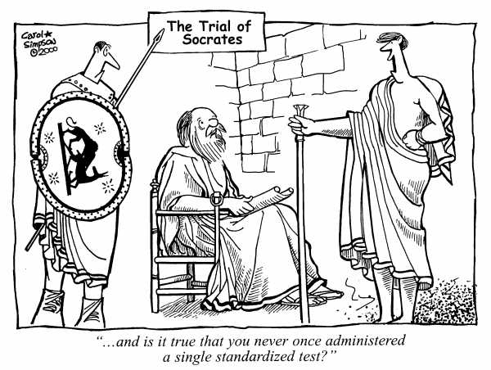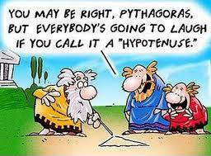
Watch this video:
https://www.youtube.com/watch?v=Q-mkVSasZIM&list=PLBDA2E52FB1EF80C9&index=5
Answer these questions completely and in detail:
- Who is Herodotus?

- Describe the Persian Empire under kings Cyrus and Darius. How did they rule their empire and how did they treat conquered people?

- What is Zoroastrianism?

- Who is Aristophanes? Why is it ironic that his works are considered boring by so many students today?

- Describe the Greek polis (city-states).

- How did the Persian Wars helps to unite the Greek city-states?

- Compare Sparta and Athens

- What is the Peloponnesian War and how did it come about?

- Why do you think Athens followed a policy of realism when their ideals spoke about democracy, philosophy, etc…? What might be a modern example of this (abandoning principles for pragmatism)?

- Why was the Greek victory in the Persian Wars important for “western” civilization?

- Why might a Persian victory have been better (at least 3 reasons)?

