Crash Course #6: Buddha and Ashoka
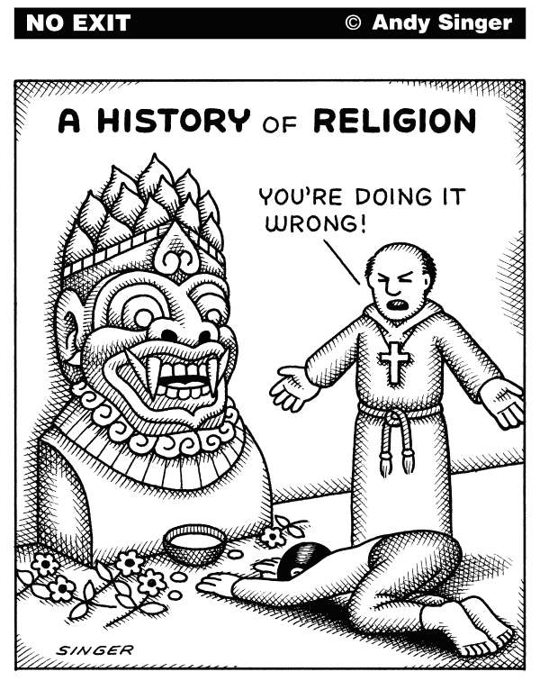
Watch this video:
https://www.youtube.com/watch?v=8Nn5uqE3C9w&index=6&list=PLBDA2E52FB1EF80C9
Answer these questions completely and in detail:
- What are the problems with studying Indian history?

- Who are the Aryans? What are the Vedas?

- Describe the caste system.

- What is dharma? How is it related to karma and samsara (reincarnation)?

- What is the importance of religious writings, such as the Vedas, Bhagadvad Gita, the Mahabharata, and the Upanishads?

- What is the ultimate goal of Hinduism (and, by extension, Buddhism)?

- How did Hinduism create social cohesion, but also hurt attempts at empire building?

- Describe the formation of Buddhism

- List the Four Noble Truths.

- Who did Buddhism appeal to? Why?

- Who is Ashoka and what did he do?

- Why is Hinduism considered to be a flexible religion? Why is it considered to be polytheistic?

