Crash Course #7: China
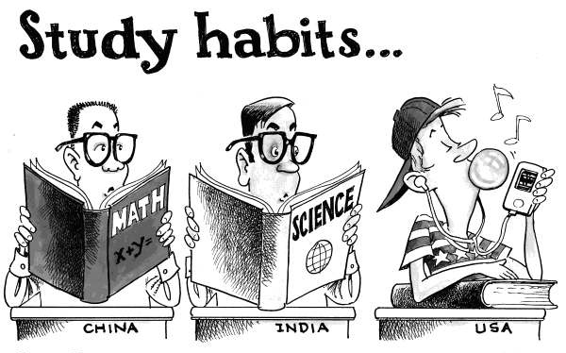
Watch this video:
https://www.youtube.com/watch?v=ylWORyToTo4&list=PLBDA2E52FB1EF80C9&index=7
Answer these questions completely and in detail:
- What is a bureaucrat? What is a bureaucracy? *Research Question*

- What years did China exist under dynastic rule?

- What is a dynasty? List the Chinese dynasties in order.

- What is the Mandate of Heaven? How did it lead to a cycle of dynasties?

- Why was the Qin Dynasty important, despite only lasting 38 years?

- Describe the life of Confucius and his philosophy. (Five Relationships and Filial Piety)

- Describe the concepts of Ren and Li. What role do family and ancestors play in this system?

- Why does John Green describe Chinese history as circular?

- What do you think about the relationship between those who make history and those who write it? Which is more important? Why? How do those who write history have power over those who make it?

