Crash Course #8: Alexander the Great (Al)
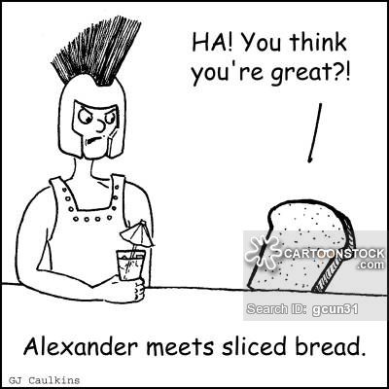
Watch this video:
https://www.youtube.com/watch?v=0LsrkWDCvxg
Answer these questions completely and in detail:
- What is John Green’s point that it is problematic giving historic figures the title “great”? Do you agree or disagree?

- Where was Alexander (Al) from?

- What are the three conceptions of Al’s greatness?

- List his accomplishments.

- What are some of the problems with Al’s accomplishments?

- What happened to Al’s empire after his death?

- Do you agree with the assertion that Al was more important after his death? Why or Why not?

- Why is Alexandria, Egypt an important city?

- Why do you think women have been “marginalized” in the story of history?

- Why do you think leaders throughout history studied and likened themselves to Al? (Napoleon and Julius Caesar)

- What other ways can we study history besides examining the deeds of “great men”?

