Crash Course #9: The Silk Road
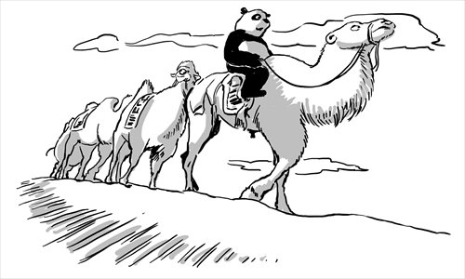
Watch this video:
https://www.youtube.com/watch?v=vfe-eNq-Qyg&index=9&list=PLBDA2E52FB1EF80C9
Answer these questions completely and in detail:
- Why is the “Silk Road” a bad name for this network of trade? Why do we use the term?

- Describe how goods travelled across the Silk Road.

- What goods were traded? From where?

- What role did nomadic groups play in this trade network?

- What do you think about John Green’s assertion that “wealth shapes politics”?

- How did the Silk Road impact lower/ middle class people?

- How was Buddhism influenced by the Silk Road?

